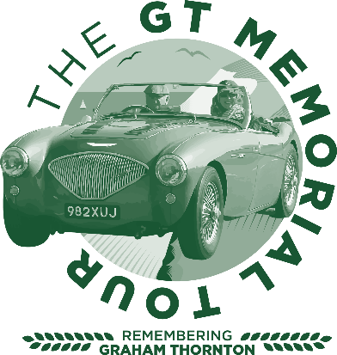

Sponsored by Hamnton Construction
Press release
All the venues are now finalised for this brand-new Charity Classic Car tour being organised by the experienced team at Bognor Regis Motor Club Ltd. The tour is being run in memory of Graham Thornton, a regular supporter on the Regis Classic Tours. He passed away from asbestos related lung cancer in January 2020.
This new tour will conform to any Covid 19 guidelines still in place on Sunday 27th June 2021. Should there still be major restrictions in place, deeming unsafe to go ahead, all entries and payments will be held over to a new date in the Autumn. The team have safety as their highest priority and there will be on-line entry and signing on. All tour packs containing a tulip roadbook, will be sealed at least 3 days before the tour to be collected at the start. Hand Sanitiser will be available.
The exclusive start will be on Peter and Mary Hall’s farm near Romsey, Hampshire. The route will then follow quiet country lanes through to Breamore House Countryside Museum where your BYO picnic lunch will be eaten along with a visit to the museum. Tea and Cake will be served by the ladies of Micheldever WI at our next exclusive venue at Duncan Hamilton Motors with a chance to view their current range of exotic classic and motorsport cars. The route will be approximately 100 miles in Hampshire and Wiltshire, finishing back at Peter and Mary’s farm with a roast beef roll.
The aim of the event is to raise lots of money for Mesothelioma UK while having a great day out with your classic travelling through beautiful countryside with like minded people. Regulations and a link to the entry form are available at www.bognor-regis-mc.co.uk then click on Events and that will lead you through to the GT Memorial Tour.
Please note the majority of the event will be held outside for safety reasons, please bring a face mask and be prepared for whatever the weather may throw at us!
Entry fee is £120.00 for a crew of 2 to include breakfast rolls and coffee/tea, entry into the venues mentioned above, afternoon tea and cake and a hog roll at the finish. Additional crew members are £60.00. £12.50 per person from every entry will be donated to Mesothelioma UK.
Special accommodation rates have been organised with Chilworth Manor Hotel for those wishing to make a weekend of it.
The entry is open to all classic cars registered before 31st December 1995, but later modern classics will be considered.
The on-line entry system opened on 27th March 2021. Already nearly 50% of the entry has been reserved. The Club are expecting entries to be at a premium as only 85 places will be available. For more details email alitherally@btinternet.com to register your interest. Entries are open to anyone with a suitable classic car. The event is totally non-competitive and participants do not need competition licences or to be members of any motor club. However, the driver must hold a full UK licence and be insured for their nominated vehicle.
Bognor Regis Motor Club have been established since the 1950’s and take pride in organising great value professionally run events including The Regis Rally, The Regis Classic Tour which ran from 1998 – 2017 and raised over £570,000.00 for Cancer charities and annual The Regis TAP (Tour And Picnic) which started in 2011 and has already raised over £40,000.00 mainly for Kent, Surrey and Sussex Air Ambulance.
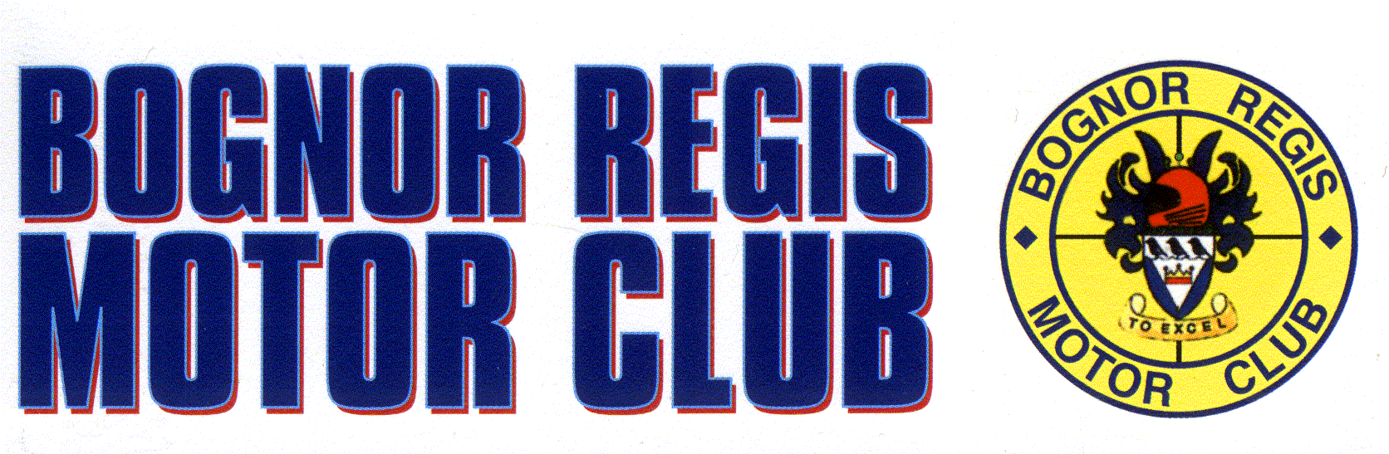
BRMC look forward to welcoming you to their latest fundraising tour.
Photo courtesy of Steve Carpenter of

Graham and Clare Thornton with their 1955 Austin Healey 100/4 on The 20th Regis Classic Tour in Holland in Spring 2017. Photo credit EDP Photo News.
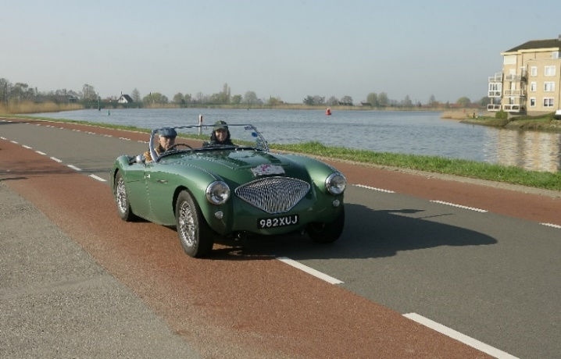

OPTIONAL PICNIC PLATTERS AT BREAMORE – Sunday 27th June 2021

For anyone not wanting to bother about bringing a picnic we have arranged with Allison Rust who runs Breamore Tea rooms that she will offer take-away Picnic Platters. This would avoid the need to keep food chilled overnight, especially for those at hotels/B & B’s before the tour and offer something different. Please order directly with Allison. Breamore Tea Rooms picnic platters all at £20.00 for 2 people sharing to include 2 hot or 2 soft drinks, a choice of gelato ice cream or a slice of homemade cake. Napkins & disposable cutlery included.

THE ANTI PASTI
Chorizo,Serrano ham, salami, manchego cheese, olives, roasted peppers & gherkins.

FISH PLATTER
King prawns, smoked salmon, local smoked trout pate, selection of crackers/Melba toast & crudités.

CHEESE PLATTER
Local mature & smoked cheddar, Stilton & Brie cheeses with crackers, chutneys & pickles, grapes & celery.

Please send your choices to allisonrust@hotmail.co.uk & she will advise you of her bank details for payment by return email. DO NOT SEND TO EITHER ALI GREEN OR JILL COLLINGS
All choices must be received by Sunday 6th June.
Please come to the tea rooms for collection & to choose your drinks etc.
In the event of having to postpone the event because of covid we will hold your payment until another date is agreed. I hope this is acceptable if you have any queries please do not hesitate to contact me.
Kind regards
Allison Rust

