5

The 16th Regis “TAP”


Sunday 6th September 2026

Generously sponsored for the sixth year by

Classic Car Tour And Picnic
Promoted By

Bognor Regis Motor Club Ltd

www.bognor-regis-mc.co.uk



REGULATIONS

Putting the FUN into fundraising for

Charity No: 1021367
Total raised for KSSAA in 14 years £70,095.31
and a further £14,380.15 for other charities from these tours.
Total overall in 15 years £84,475.46

The 16th Regis “TAP”
Sunday 6th September 2026

Regulations

Important note:

Public opinion of our hobby and sport is under more scrutiny than ever, especially regarding environmental issues. Therefore, it is important to have a positive approach to mitigating our emissions to ensure a secure future for our chosen hobby and Motorsport in general. As in previous years, there will be a donation per car included in the Entry fee. This money will be donated to Sussex Wildlife Trust towards their “Help our Kelp” fund to restore the Kelp forests off the Sussex Coast.

https://sussexwildlifetrust.org.uk/what-we-do/living-seas/kelp/help-us-regenerate-sussex-kelp-forest

ORGANISATION
- Bognor Regis Motor Club Ltd will organise their 16th Regis “TAP”. A Touring Assembly & Picnic on Sunday 6th September 2026. This is a non-competitive tour giving participants the opportunity to drive a scenic route and visit some interesting locations along the way.

2. The event will be held under a Certificate of Exemption – Touring Assembly Permit issued by Motorsport UK, these Regulations & any written instructions that the Organisers may issue for the event. The event has no competitive element. A Competition Licence is not required for the event. Entrants do not need to be members of the organising Club or any other motoring organisation but need a full driving licence.
Motorsport UK Event Permit/Certificate of Exemption No: TBA

ELIGIBILITY
3. The event is open to four-wheeled road cars first registered before 31st December 1995. Pre-1960 registered light commercial vehicles will be considered upon application. Interesting later cars will be accepted at the organiser’s discretion.

ENTRIES
4. Entries open as the entry system goes live at www.bognor-regis-mc.co.uk on 3rd January 2026 for previous participants, 10th January to new participants and closes on 12th August 2026. All entries must be made on the official entry form and be accompanied by the entry fee of £140.00 for two people travelling in one car (£70.00pp). Please add £67.50 for each additional passenger up to the number of seats in the vehicle. Please make your cheque payable to Bognor Regis Motor Club Ltd. See entry form for BAC payments which is the preferred method of payment please. Each entry will be acknowledged (preferred method email). As in all previous years, £12.50 per person from every entry fee will be donated to KSS-Kent Surrey Sussex, Air Ambulance Charity, subject to the minimum entry being received.

The entry fee includes: One Tulip Roadbook giving a suggested route and pre-arranged venues to visit during the tour, One rigid Tour Plate & two window stickers. Breakfast roll with tea/coffee at our exclusive private start venue, Great Ballard School, Eartham, PO18 0LR by kind permission of Sue Jay. Our Bring your Own Picnic Lunch venue is at another new venue: Stansted Park Estate www.stanstedpark.co.uk. The visit here will include a chance to view the House, parkland, Arboretum Garden Centre & Café (should you fail to bring your own picnic – however it is only small and gets very busy! Our afternoon visit is at Winchester Auto Barn at Sutton Scotney SO21 3NS. Here you’ll be able to enjoy tea/coffee and cake and view the Showroom. Winchester Auto Barn & Drivers Club | Sutton Scotney, Winchester. The finish will be at another exclusive private venue at The Tithe Barn, Old Ditcham Farm, GU31 5RQ near Petersfield again by kind permission of Jeremy & Margaret Oates MR: 197/7605 2035. There you will be served a delicious Roast Meat roll by Matt’s Hog Roast. Bring your own drinks & plastic glasses.
Don’t forget to bring your own picnic and chairs as you may need them at all the venues.

The maximum number of cars on the event is 90 with 10 reserves. The minimum is 60. Should the above minimum figure not be reached, the organiser’s reserve the right to cancel the event and entry fees will be refunded as per item 6. Cars will be generally seeded in age order with the oldest cars leaving first. If you wish to travel with friends let us know on the entry form and we will try to accommodate your request.

5. Well behaved dogs on leads will be allowed at all outdoor venues. No dogs inside the buildings please at any of the venues. You must pick up and dispose of poo responsibly at ALL venues!

CANCELLATION OF ENTRY
6. The following cancellation fees will apply: Cancelling entry after taking a reserved & paid for place before 12th August 2026 – entry fee will be refunded less £12.50 donation per person for KSS Air Ambulance Charity & £5 administration fee. Entry cancelled after 12th August 2026 – Sorry no refund.

ROUTE
7. The Start venue will be Great Ballard School, Eartham, PO18 OLR. Map Ref:197 / 9390 0940. The first car will leave at 10.01am. The suggested route will cover approximately 100 miles in West Sussex Surrey and/or Hampshire. The Finish will be at The Tithe Barn, Old Ditcham Farm, near Petersfield. GU31 5RQ. MR: 197/7605 2035

8. The suggested route will be given in an easy to follow “Tulip” Road Book, which will be issued to entrants at the start of the event. Although not required to complete the suggested route, participants may like to follow their progress on Ordnance Survey 'Landranger' 1:50000 maps: 185, 186 and 197 (to be confirmed) or a good quality up to date road atlas. A marked map will be available for you to copy at the start.

9. Route cards will be supplied but will not be stamped or signed this year. The venues will be open for specified periods, as shown, giving adequate time to visit them while they are open.

EVENT PHOTOGRAPHER
10. We are delighted to confirm that Robert Clayson has agreed again to be our official photographer. www.robertclayson.co.uk

TIMETABLE
11. The timetable for the event will be as follows:
3rd January 2026: On-line Entries open to previous participants and open to new participants at the
Historic Rally Car Register Open Day at the British Motor Museum, Gaydon on 10th January 2026
12th August 2026: On-line entries close
23rd August 2026: On-line Motorsport UK Signing-on opens, Final Instructions, Driver’s Brief and Seeded entry list will be posted onto the website.
Sunday 6th September 2026: 08.15 – 09.45. Arrival at Great Ballard School, Eartham, park up, collect pack and Breakfast rolls. There is a strict timetable this year – please be on site by 09.45 at the very latest.
10.00: Any crew, not present at the venue, may not be allowed to start and may forfeit their entry to a reserve. 10.01: First car leaves the start at Great Ballard School with cars following at 1 minute and/or under intervals.
17.00: Approximately first car due back at the finish at The Tithe Barn, Old Ditcham Farm, Ditcham

DOCUMENTATION
12. Cars/Entrants must arrive at the start between 08.15 - 09.45.
All participants must ensure that they have a current MOT Certificate and Road Fund Licence (if needed) plus adequate insurance to enter the event for the vehicle entered. They will be required to confirm a declaration to this effect on the Entry Form by 12th August 2026.

13. Any vehicle, which, in the opinion of the organisers, is deemed inappropriate or unsafe, will not be allowed to start. Cars must not display any advertising or carry any competition numbers on the doors, without prior permission from the organisers. Please ensure your vehicle is in a safe, clean and tidy condition. There will be no Scrutineering at the venue.

14. At Great Ballard entrants collect their Tour Pack containing: Tour Plate, window stickers, Road Book and Route Check Card. They will also receive wrist bands for breakfast roll/coffee or tea, visit to our picnic venue, visit with afternoon tea still being finalised and Roast Meat roll, with tea/coffee (one each per person) at the finish at The Tithe Barn, Old Ditcham Farm.

Please note there will be no cash bar at the finish. Please bring your own drinks & plastic glasses if
you require anything.

OFFICIALS
15. Clerk of the Course & Secretary to the Meeting: Ali Green – Landline: (01243) 542674
email: alitherally@btinternet.com. On the day Mobile: 07803 604453
Route Designer: Mick Briggs
Club Safeguarding Officer: Kevin Lawrence
Entries Secretary: Mrs Jill Collings, 12 Brecon Avenue, East Cosham, Portsmouth, Hants, PO6 2AW by 12th August 2026. Tel: 02392 325868 (before 21.00 hours please) or email: Jill Collings jocollings12@yahoo.co.uk
Marshals: Members and friends of Bognor Regis Motor Club Ltd

COMMEMORATIVE GIFT
16. There will be a small Commemorative Gift presented to all participants who enter the tour.

ACCOMMODATION
17. A list of Tourist Board approved accommodation in the area from the following websites: www.sussexbythesea.com or visitchichester.org should provide suitable suggestions.

ADDITIONALLY
18. There will be a calculated figure in the entry fee for helping to offset carbon on this event. To include organisation, participation, travel to and from the tour for both Marshals and Participants. Money received will be donated to Sussex Wildlife Trust.

19. Participants will be identified by a rigid tour plate, which will be supplied by the organisers. This must be displayed in a prominent forward facing flat position on the front of the vehicle, cable ties will be provided.

20. All marshals are deemed to be judges of fact regarding driving standards. You may be excluded and your road book retained for inconsiderate driving, so be warned! Please drive responsibly, respecting the road conditions and other road users, our marshals and the staff at our venues, ramblers, dog walkers, horses and cyclists.

21. There will be a raffle at the finish, if anyone has any unwanted bottles of wine or spirits or Motorsport/Motoring related items or tickets to upcoming events and wishes to donate them please let Jill know and bring them to the start. A 2025 Regis TAP photobook will be Auctioned at the finish.

22. Brit Assit will again be providing voluntary on event emergency repairs but not recovery. We are very grateful to Norman Winchester for his continued very generous support of The Regis TAP.

Privacy policy: By entering this event you have given us permission to hold your contact information. This will only be used to advise you of this event and future events where BRMC is involved and you may find of interest. Your details will not be shared or sold. The Organising Team and Committee of the club are not professional computer operators but will endeavour to ensure your information is held securely as will Tony Michaels of MTC1.

For anyone wishing to advertise their business or services to participants and marshals on the event we would be delighted to accept advertisements for the Roadbook. The cost is £100 for a full page or £150 for a double page with the advertiser providing PDF artwork ready for printing in A4 portrait style before Mid-July. All proceeds from this promotion will be added to the funds raised for Kent, Surrey & Sussex Air Ambulance.


Putting the fun into Fundraising for

Acknowledgements:
KSS Air Ambulance Charity Kent Surrey Sussex: www.kssairambulance.org.uk
Bognor Regis Motor Club Ltd: www.bognor-regis-mc.co.uk
Brit Assist: www.britassist.eu
Great Ballard School: www.greatballard.co.uk
Hardy Engineering: www.hardyengineering.co.uk
Historic Rally Car Register: www.hrcr.co.uk
Matt’s Hog Roast: www.matt-hogroast.co.uk
Motorsport UK & Route Liaison Officers – www.motorsportuk.org
Robert Clayson – www.robertclayson.co.uk
Sidlesham Garage: www.sidleshamgarage.co.uk
Stansted Park: www.stanstedpark.co.uk
The Historic Rally Car Register www.hrcr.co.uk
Tony Michaels on-line entry system: www.mtc1.uk
The Tithe Barn, Ditcham Park Farm www.tithe-barn.co.uk

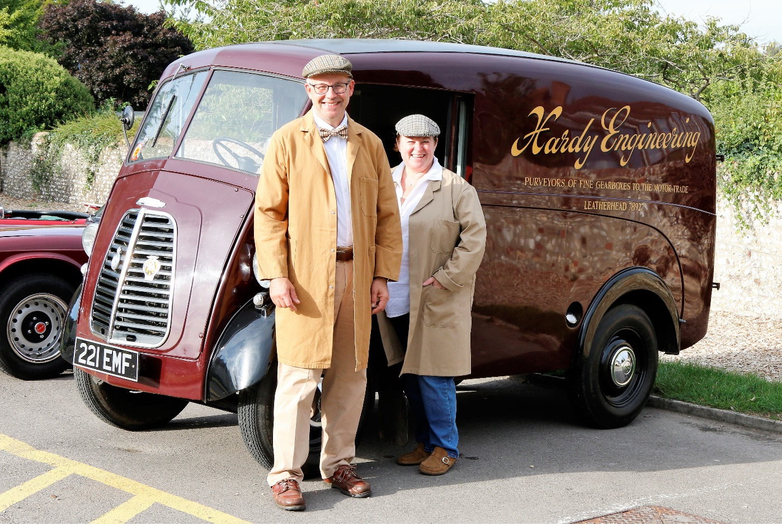
One of our lovely sponsors from Hardy Engineering with their 1955 Morris J Type Van.
Neil being much younger but just as well preserved! Photo courtesy of Mick Briggs

We hope you enjoy your day's Motoring and help us to raise plenty of funds for

KSS Air Ambulance Kent Surrey Sussex. Charity No: 1021367.

